DALLAS-FORT WORTH INTERNATIONAL AIRPORT BOARD

CONCESSIONS BUSINESS DISCLOSURE FORM
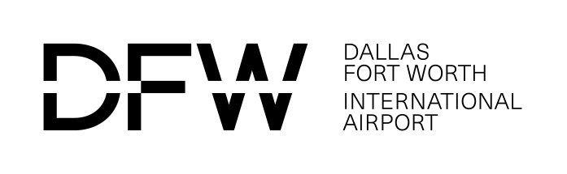

It is recommended this form be completed by a governing person, governing authority, or legal counsel.
Information about Entity Submitting Bid/Proposal/Offer
(This information must match the information provided on the Bid/Proposal/Offer. )
Business Name:
Business Address: |  |  |  |  |  | Mailing Address:
City |  | State | Zip |  |  | City | State |  | Zip
Business Web Address:
Business Phone: |  |  |  |  |  | Business Fax:
Contact Person: |  |  |  |  |  | Contact’s Phone No.:
Contact’s E-Mail Address:
- Entity Ownership Information
(Check the appropriate box and provide requested details below.)
Business Structure: (Please check only one box)  Partnership Limited Partnership |  |  |  | Limited Liability Partnership
Sole Proprietorship | Joint Venture |  |  |  | Limited Liability Company |  |  | Corporation (“C”)
IF CORPORATION, please check all the type(s) below that are applicable:
For Profit or Non Profit Public or Private
S Corporation Professional Parent-Subsidiary Close
State of Incorporation, Registration or Formation:
State: Month: Year:
Name(s) of Owner(s), Partners or Owner of DBA (include ALL investors with a financial interest or other ownership interest). Please indicate if any such individual(s) were employed by DFW Airport and the dates employed:

Name(s) of Joint Venture Participants (include ALL investors with a financial interest or other ownership interest). Please indicate if any such individual(s) were employed by DFW Airport and the dates employed:

UNLESS PUBLICLY TRADED list all individuals, partnerships, corporations or other legal entities having ownership interests in the business and indicate their percentage of ownership. Please indicate if any such individual(s) were employed by DFW Airport and the dates employed. Attach additional sheets if necessary. NOTE: Attach a copy of the Certificate of Formation or Joint Venture Agreement.

Form Completion Date:
Failure to properly complete and submit this form with the bid/proposal/offer may cause the bid/proposal/offer to be considered non-responsive.
Form Revised 10/13

Concept Name:
Concession Location ()
 | A |  |  | B |  | C |  |  | D |  |  | E |  | E Satellite |  |  | RCC |  |  | Other
Concession Type ()
 |  | Food and Beverage |  |  |  |  |  |  |  |  | Passenger Amenities |  |  |  | ACDBE Goal Assigned |  |  |  | %
 |  | Retail |  |  |  |  |  |  |  |  | Other |  |  |  | M/WBE Goal Assigned |  |  |  | %

Concept will be Owned by the Following Entities: (Attach additional sheets if necessary)

Concept will be Owned by the Following Entities:
(Attach additional sheets if necessary) The total sum of all Percentage should be 100%

Entity | Owner | Percentage (%) | Are you related to other owners?  (Y or N) | Relationship status; e.g. spouse, cousin, child etc.
1
2
3

Entity 1 Information:
(Attach additional sheets if necessary)

Entity 1 | Owner | Percentage (%) | Are you related to other owners?  (Y or N) | Relationship status; e.g. spouse, cousin, child etc.

Entity 2 Information:
(Attach additional sheets if necessary)

Entity 2 | Owner | Percentage (%) | Are you related to other owners?  (Y or N) | Relationship status; e.g. spouse, cousin, child etc.

Entity 3 Information:
(Attach additional sheets if necessary)

Entity 3 | Owner | Percentage (%) | Are you related to other owners?  (Y or N) | Relationship status; e.g. spouse, cousin, child etc.

