Exhibit B: Concessions Business Disclosure Form

Filling out a Concessions Business Disclosure Form for the DFW International Airport Board

- Please make sure you have the correct version of the form, it should read “Issue Date 10/13” in the bottom right corner.
- Use 10 pt. font with no bold, italicized or underlined words on the form.
- Please make sure you include your entire business name on the form and it matches what is listed on your contract.
- If you are a corporation, limited partnership, limited liability partnership or Limited Liability Company, your business name should include that designation or an abbreviation of that designation.
- If the mailing address is the same as the business address, write “Same” in the space under mailing address. Do not copy the mailing address or leave blank.
- Do not bold or underline the web or email addresses.
- Please ensure the contact person’s information is up to date.
- Under business structure check only one box. The next section is filled out only if your company is a corporation.
- If your business is a corporation, check the box for profit or nonprofit, and public or private. These boxes must be checked. (Hint: to
make an “x” just double-click on the box and select the “checked” option). If you are an S corporation, professional, parent-sub, or close “x” the appropriate box as well.
- The state, month and year of your company’s incorporation, registration or formation ALWAYS needs to be filled in. This is either the date you registered with the County Clerk, or filed with the Secretary of State.
- List the names of ALL Investors with a financial interest or other ownership interest in the company. If the company is publicly owned please list the stock exchange it is traded on and the symbol. If your company is traded on a foreign exchange please name the foreign exchange is traded on.
- Fill in names of Joint Venture owners if applicable.
- The percentage of ownership needs to be filled in unless the company is publicly traded. ALL of the Investors with a financial interest or other ownership interest in the company need to be listed with their corresponding percentages of ownership in this space. Please use whole or half numbers. NOTE: Attach a copy of the Certificate of Formation or Joint Venture Agreement, if applicable.
- The form should be accurate as of proposal submittal date.

DALLAS-FORT WORTH INTERNATIONAL AIRPORT BOARD

CONCESSIONS BUSINESS DISCLOSURE FORM
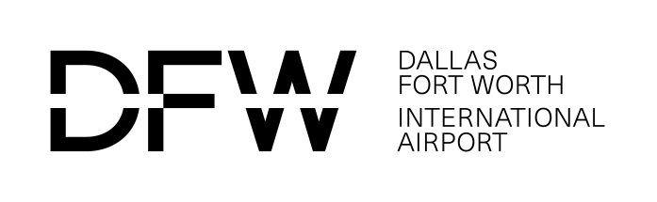

It is recommended this form be completed by a governing person, governing authority, or legal counsel.
Information about Entity Submitting Bid/Proposal/Offer
(This information must match the information provided on the Bid/Proposal/Offer).

Package Number: _______________________________________
Business Name:
Business Address: |  |  |  |  |  | Mailing Address:
City |  | State | Zip |  |  | City | State |  | Zip
Business Web Address:
Business Phone: |  |  |  |  |  | Business Fax:
Contact Person: |  |  |  |  |  | Contact’s Phone No.:
Contact’s E-Mail Address:
- Entity Ownership Information
(Check the appropriate box and provide requested details below.)
Business Structure: (Please check only one box)  Partnership Limited Partnership |  |  |  | Limited Liability Partnership
Sole Proprietorship | Joint Venture |  |  |  | Limited LiabilityCompany |  |  | Corporation (“C”)
IF CORPORATION, please check all the type(s) below that are applicable:
For Profit or Non- Profit Public or Private
S Corporation Professional Parent-Subsidiary Close
State of Incorporation, Registration or Formation:
State: Month: Year:
Name(s) of Owner(s), Partners or Owner of DBA (include ALL investors with a financial interest or other ownership interest). Please indicate if any such individual(s) were employed by DFW Airport and the dates employed:

Name(s) of Joint Venture Participants (include ALL investors with a financial interest or other ownership interest). Please indicate if any such individual(s) were employed by DFW Airport and the dates employed:

UNLESS PUBLICLY TRADED list all individuals, partnerships, corporations or other legal entities having ownership interests in the business and indicate their percentage of ownership. Please indicate if any such individual(s) were employed by DFW Airport and the dates employed. Attach additional sheets if necessary. NOTE: Attach a copy of the Certificate of Formation or Joint Venture Agreement.

Form Completion Date:
Failure to properly complete and submit this form with the bid/proposal/offer may cause the bid/proposal/offer to be considered non-responsive.
Issue Date 10/13

Concept Name:
Concession Location ()
 | A |  |  | B |  | C |  | D |  |  | E |  | E Satellite |  |  | RCC |  |  | Other
Concession Type ()
 |  | Food and Beverage |  |  |  |  |  |  | Passenger Amenities |  |  |  |  | ACDBE Goal Assigned |  |  |  | %
 |  | Retail |  |  |  |  |  |  | Other |  |  |  |  | M/WBE Goal Assigned |  |  |  | %

Concept will be Owned by the Following Entities: (Attach additional sheets if necessary)

Concept will be Owned by the Following Entities:
(Attach additional sheets if necessary) The total sum of all Percentage should be 100%

Entity | Owner | Percentage (%) | Are you related to other owners?  (Y or N) | Relationship status; e.g. spouse, cousin, child etc.
1
2
3

Entity 1 Information:
(Attach additional sheets if necessary)

Entity 1 | Owner | Percentage (%) | Are you related to other owners?  (Y or N) | Relationship status; e.g. spouse, cousin, child etc. | Email | Phone Number

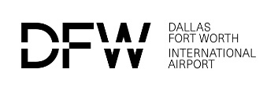

Entity 2 Information:
(Attach additional sheets if necessary)

Entity 2 | Owner | Percentage (%) | Are you related to other owners?  (Y or N) | Relationship status; e.g. spouse, cousin, child etc. | Email | Phone Number

Entity 3 Information:
(Attach additional sheets if necessary)

Entity 3 | Owner | Percentage (%) | Are you related to other owners?  (Y or N) | Relationship status; e.g. spouse, cousin, child etc. | Email | Phone Number

